ASIA PACIFIC INSTITUTE OF INFORMATION TECHNOLOGY
Level 4

COMP40004 WEB DEVELOPMENT AND OPERATING SYSTEMS

Individual Assignment

You are required to design and implement a simple web application which demonstrates the usage of proper web standards. This document consists of two assignments.

Learning Outcomes

Upon completion of this assignment, you will be expected to achieve the following learning outcomes:
- DESIGN, PROGRAM AND TEST A WEB APPLICATION USING CURRENT WEB STANDARDS, AND IN DOING SO ADDRESS TARGET AUDIENCE AND DEVICE IN THE PROCESS SO THAT THIS WORKS EFFECTIVELY FOR MOBILE AND OFFLINE USE
- IMPLEMENT AND TEST AN EVENT DRIVEN WEB APPLICATION USING CURRENT CODING STANDARDS AND PRACTICES

Assignment submission
To be submitted as specified in the consolidated SAIS.
Assignment 2 – 30%
Covers requirements from 1 to 10
- A PDF document containing wire-frames – In Submission Link
All documents must be uploaded in PDF format without Zipping to the submission Link
- A link to your web application online and project folder – In Submission Link
- A project folder with all necessary project files

Assignment 3 – 30%
Covers requirements from 11 to 14
- A PDF document containing activity diagrams and test results – In Submission Link
All documents must be uploaded in PDF format without Zipping to the submission Link
- A link to your web application online – In Online Forum

Technical Requirements
The solution needs to be implemented using HTML, CSS and ECMAScript. (Standard in Java Scripts) with NO external web creator tools or any external libraries.

Scenario

You have been asked to create a client-side web application to showcase “Turtle hatcheries in Sri Lanka”. The need arose by the government of Sri Lanka to protect the turtle population in Sri Lanka. They need to provide tourists an overall view of the turtle population via the website. You need to show your skills in web development, including web design, creating pages with HTML, styling using CSS, scripting with ECMAScript and testing web applications.
The application should be designed so it is a showcase of you and your skills, suitable to market yourself later to prospective employers.
The cite map for the application is shown below:

Application

Home Page
Turtle categories
Threats to turtles

Kosgoda
Other turtle hatcheries

Bentota
Purchase and
Donate page
Hikkaduwa turtle hatchery

Assignment 2

Your application must fulfil the following criteria:

- Your whole application must:
- be created using JUST HTML, CSS, ECMAScript and NO external web creator tools
- NOT contain any external libraries or frameworks other than the ones covered in class
- have minimum of 7 HTML pages and are not limited to:
  - Home page
  - Turtle categories
  - Hikkaduwa turtle hatchery
  - Threats to turtles
  - Other turtle hatcheries
    - Kosgoda
    - Bentota
  - Purchase and donate page

- Your whole application must be a progressive web application and therefore must:
- be hosted on HTTPS
- contain a web manifest with icon files
- contain responsive images for different screen resolutions

- Your whole web application should be styled using JUST CSS ensuring that it:
- is suitable for the target audience
- is responsive on all pages from mobile devices to desktop devices
- uses a link tag in the head of the HTML and has NO style within the HTML documents
- works on all modern browsers
- shows appropriate number of columns on mobile and desktop
- shows responsive tables
- shows how animation can help the user experience by providing items the user can interact with
- shows your skills in DRY standards conformant CSS

- Each page must contain suitable and appropriate HTML for the following:
- the head section
- a navigation section with appropriate links
- at least one header and footer
- References of content as comments in the footer area
- semantic tags for elements, sectioning, grouping, text and media

- The Home page must contain the following:
- An introduction of the Sri Lankan turtle population
- a suitable responsive main image
- 3 sub-sections each having
  - a suitable image
  - at least two paragraphs of suitable content
  - appropriate headings
- all the following items somewhere on the page
  - a bullet point list of suitable content
  - a numbered list of suitable content
  - HTML comments for use by developers, which are not displayed on the page

- Turtle categories page must contain the following:
- suitable content about different turtle categories in the country (each category needs to have a name, a map to the beaches which has high population densities, images and a description)
- a summary table showing suitable content about specific categories of turtles we can find in the country you mentioned above:
  - You can select which data to present here e.g.: name of the turtle, where it is found, image etc
- the table must have
  - appropriate headings
  - at least 3 columns and at least 3 rows
  - a table footer

- Hikkaduwa turtle hatchery page will contain the following:
- Appropriate images to showcase the turtle hatchery
- A small description of the hatchery and things you can do there
- Google location/ map of the hatchery

- Threats to turtles’ page will contain the following:
- Descriptions of at least 3 main threats to the turtle population.
- 3 sections (one for each threat), having:
  - an appropriate image
  - a brief description of the threat, consequences and how we can prevent
  - an appropriate link to a suitable solutions/ conservation
- A link for the 2 other hatcheries pages (Kosgoda and Bentota) (details of the 2 hatcheries pages is shown in question 9)

- Other turtle hatcheries pages. (There should be 2 pages which showcases Kosgoda and Bentota turtle hatcheries)
- these two pages must have identical HTML
- the HTML pages must have at least the following
  - a main image
  - at least one other image
  - at least 3 sections
  - a header and a footer
  - a navigation section with appropriate links
- each page must link to a separate CSS
- each page must be styled in a totally different way to demonstrate that the same HTML can have a different appearance dependent on the CSS
- each page must have at least one animation

- Purchase and Donate page
- This page should showcase types of donations tourists could make for the betterment of the turtle population in the country.
- Page should also showcase several local merchandise tourists could purchase.

Tasks

You will need to hand in the following
A copy of PDF document containing wireframe designs
A link to your web application online

- Design your web application showing low fidelity wireframes for all your pages in a desktop and mobile layout
- Build your web application as per the specification shown above
- Create a word document report and convert it to PDF which shows the following
- A proper introduction
  - Your designs
  - A link to your web application which we will use to assess your application
  - Conclusion

Marking Criteria
Task | Marks
Report/Application - Design  - Your design of your web application in a low fidelity wireframe format  - The suitability of the visual design of the final web application | 10
Application  - your conformance to the specification requirements 4-10  - your implementation of good quality code | 10
Application – Progressive Web Application  - your conformance to the specification requirements 1-2  - your implementation of good quality, well-structured code  - the efficiency of the code | 10
Application – Site CSS  - your conformance to the specification requirements 3  - your implementation of good quality code | 10
Application – CSS Skills  - your conformance to the specification requirements 9  - your implementation of good quality code | 10
Report / Application - Overall discretionary mark  - your consideration of good practices  - your use of innovative approaches to the problem  - your demonstration of high-level coding skills  - robustness of the final web application | 10
TOTAL | 60

Note: 30% is taken from the total as the final mark
Marks allocated as follows:
0 = no evidence of meeting criteria
1-3 = poor attempt at meeting criteria
4-5 = some attempt at meeting criteria
6-7 = good attempt at meeting criteria
8-10 = excellent attempt at meeting criteria

Assignment 3
The Hikkaduwa turtle hatchery page provides a Button as ‘Book Now’. If a user clicks that button, the website should be redirected to a new ECMA Script application to Pre-book tickets for visitors and guarantee their spot at the centre. (hereinafter let's say this new page as ‘Tickets’ page). This page should consist of the following things.

Tickets page

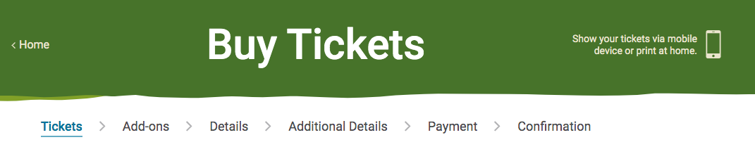
- At the very top of the page heading should be “Buy Tickets”. But it should appear on top of a cover page. For an example see the below figure.

- This page mainly has three subsections as “Dates”, “Guests” & “Duration”. Each of these sections have been described properly below.

Dates
Users should be able to select dates for his visit from an embedded calendar as follows.
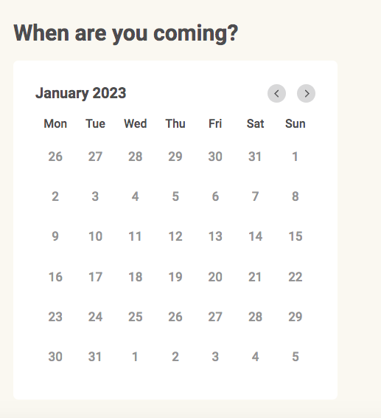

- Here only any single date should be able to select and multiple date (or range) selection should be disabled.
- Selected date should be stored in the browser's local Storage. (You have to use this later part of this application)
Guests

- Tickets are categorized under five main categories which are as follows.
  - SL Adult
  - SL Child
  - Foreigner Adult
  - Foreigner Child
  - Infant

- In front of the above each category user should be able select the number of tickets which he/she needs from each category. Following is a sample of such a case. But please note that the following is a sample only and you need to use 5 categories as mentioned above.
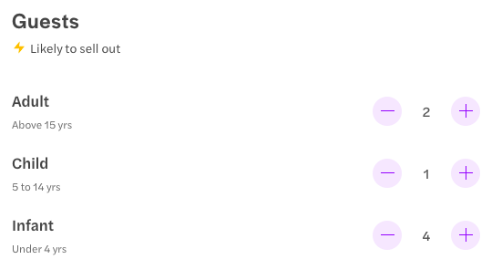

- Here also selected options should be stored in the browser's local Storage.

Duration
Visitors should be able to select duration from a drop down menu. The Hikkaduwa turtle hatchery will operate all seven days of the week from 07.00 am to 6.00 pm. Whole day has been divided to 1 hour based time slots and the drop down list will have options as follows.

07.00 am - 08.00 am
08.00 am - 09.00 am
..
..
..
10.00 am - 11.00 am (Peak)
..
..
..
5.00 am - 6.00 pm (Peak)
- Users will be charged based on 1 hour based time slots.
  - Charge per one Normal hour for Foreigner Adult - 10 USD
  - Charge per one Peak hour for Foreigner Adult - 13 USD
  - Charge per one Normal hour for Foreigner Child - 5 USD
  - Charge per one Peak hour for Foreigner Child - 8 USD
  - Charge per one Normal hour for SL Adult - 4 USD
  - Charge per one Peak hour for SL Adult - 6 USD
  - Charge per one Normal hour for SL Child - 2 USD
  - Charge per one Peak hour for SL Child - 3 USD

- Please note that every day from 10.00 am to 1.00 pm and from 3.00 pm to 6.00 pm will be considered as Peak hours.
- Users should be able select one single one hour time slot or multiple consecutive one hour time slots from the drop down menu.
- Also for Infants (SL or Foreigner) (under 4 years) entrance is completely free.
- Also the above pricing list should be displayed to the user in a table.
- Summary of the order and total payable should be displayed on the right-hand side’s column of the page as follows. As an example, let’s say someone is booking for 2 SL Adults, 3 SL Child, 1 Foreigner Adult, 2 Foreigner Child and 3 Infants group from 08.00 am to 11.00 am. Then the summary table will look as follows. (hereinafter let’s call this “summary table”)

Date | 25/02/2023
Time | 08.00 am to 11.00 am
Duration | 3 hrs ( 02 Normal : 01 Peak)
Tickets | Charges
2 SL Adult | $28
3 SL Child | $21
1 Foreigner Adult | $33
2 Foreigner Child | $36
3 Infant | Free
Total Payable | $118

- Please note that these table values should be dynamically changed, if the user changes some selected inputs.
- Above table values should be stored in the browser's local Storage.
- When this page loads for the first time, the initial table looks like as shown below.
Date | <current_date>
Time | 07.00 am to 08.00 am
Duration | 1 hrs ( 01 Normal : 00 Peak)
Tickets | Charges
1 Foreigner Adult | $10
Total Payable | $10

- At the bottom of this webpage should have a button as “Continue with purchase” and if the user completes all information correctly, this button should be enabled (by default this button should be disabled). For an example see the below figure.
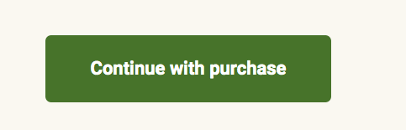

- Then if the user clicks on this button it will be redirected to another new page as “Details” page.

Details page

- In here also “summary table” should be displayed from the right hand side of the page. To load values to the table you can use the local Storage.
- Here also the top of the page should be the same as the “Tickets” page (Heading and cover photo should be the same). That page should have a small subheading as “Enter your details”. Under that you should collect the following information from the user.

Enter your details

- Full Name (required field)
- Mobile Number (required field)
- Email (required field)
- Confirm Email (required field)
- Gender (should be a drop down menu and options are ‘Male” and “Female”, this is an optional field).
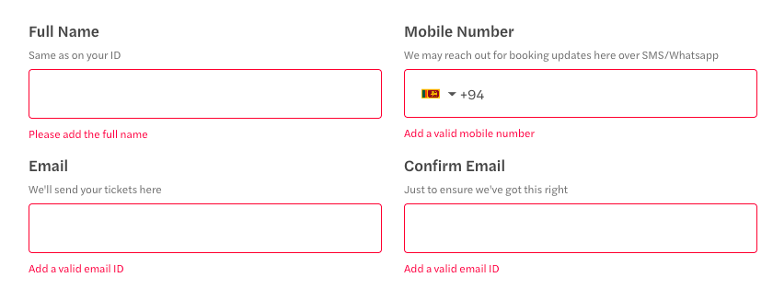

- You should also implement a form validation (see the above figure as an example).
- For the ‘Mobile Number’ part, the user should be able to select his or her country from a dropdown list and should be able to see the country code and flag. For an example check the figure below.
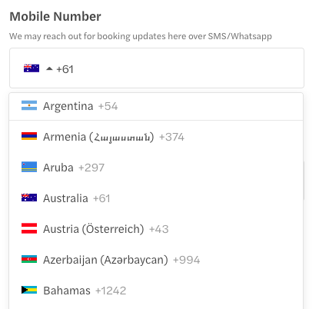

- Here also all user inputs should be stored in the browser's local Storage.
- At the bottom of this webpage should have a button as “Continue with purchase” and if the user completes all information correctly, this button should be enabled (by default this button should be disabled). (same as previous)
- Then if the user clicks on this button it will be redirected to another new page as “Payment” page.

Payment page
- In here also “summary table” should be displayed from the right hand side of the page. To load values to the table you can use the local Storage.
- Here also the top of the page should be the same as the “Tickets” page (Heading and cover photo should be the same). That page should have a small subheading as “Payment details”. Under that you should collect the following information from the user.
  - Card number
  - Expiry date
  - CVC / CVV
  - Name on card
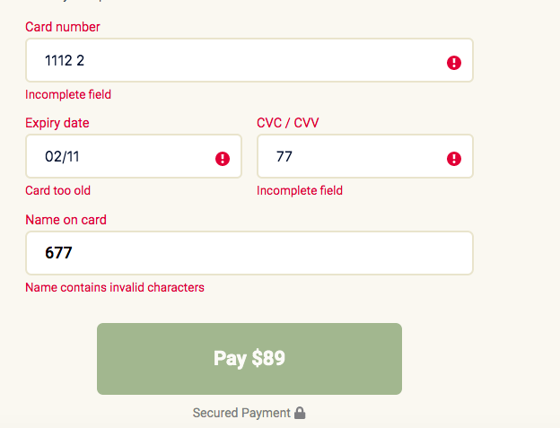

- You should also implement a form validation (see the above figure as an example).
- If user entered all data correctly, “Pay <amount>” button should be enabled and if user click that button, website should be redirected to a new page as “Confirmation”

Confirmation page
- Here also the top of the page should be the same as the “Tickets” page (Heading and cover photo should be the same).
- This page should have a subheading as “Confirmation”. Under that you should display the following message.
Thank you for your order. Your order has been confirmed with us. You can show this confirmation at the entrance. Following is the summary of your order.

Name | John Andrew
Date | 25/02/2023
Time | 08.00 am to 11.00 am
Duration | 3 hrs ( 02 Normal : 01 Peak)
Mobile | (+1) 178 923 1234
email | john@gmail.com
Gender | Male
Tickets | Charges
2 SL Adult | $28
3 SL Child | $21
1 Foreigner Adult | $33
2 Foreigner Child | $36
3 Infant | Free
Total Payable | $118

- To load values to the table you can use the local Storage.

Tasks
You will need to hand in the following.
- A copy of PDF document containing test results
- A complete source code of the fully functioning application as a single Zip file
- A link to your web application online

A.) Build your application as per the specification shown above

B.) Test your web application and create a test table showing your tests for the following
- HTML Validity
- CSS Validity
- Accessibility using WAVE
- Lighthouse testing
- Responsiveness on different devices and browsers
- Test tables for different set of user input combinations

C.) Create a document (in PDF format) which shows the following
- A proper introduction
- Your test results in the form of a test table
- A link to your web application which we will use to assess your application
- Conclusion
Special Notes:

- Please note that, above images/diagrams are only for demonstration purposes to get you to have a better understanding about the application. You should use your own designs, styles, colors, themes for your application.

- Before the final submission, several evaluations (milestone wise) will be carried out during the semester to monitor progress of your work. Further instructions will be sent by the module lecturer during the lectures. Please note that these milestone evaluations will carry forward marks for the final evaluation.

Marking Criteria
Task | Marks
Report - Activity diagrams  - your activity diagrams for the basic coffee ordering program and the advanced features | 10
Application – basic ticket purchase and donation  - your conformance to the specification requirements 11-12  - your implementation of good quality, well-structured code  - the efficiency of the code | 15
Application – advanced ordering features  - your conformance to the specification requirements 13  - your implementation of good quality, well-structured code  - the efficiency of the code | 10
Report / Application – Testing  - the thoroughness of your testing table  - the results from tests  - HTML validity, CSS validity, Accessibility using WAVE, Lighthouse testing  - Responsiveness on different devices and browsers, Tests for your ticket reservation application | 15
Report / Application - Overall discretionary mark  - your consideration of good practices  - your use of innovative approaches to the problem  - your demonstration of high-level coding skills  - robustness of the final web application | 10
TOTAL | 60

Note: 30% is taken from the total as the final mark
Marks allocated as follows:
0 = no evidence of meeting criteria
1-3 = poor attempt at meeting criteria
4-5 = some attempt at meeting criteria
6-7 = good attempt at meeting criteria
8-10 = excellent attempt at meeting criteria

